**BTEC Extended Certificate**

in Creative Digital Media Production

**UNIT 2: Planning and Pitching a Digital Media Product**

Planning, pitching and presenting ideas and information to a client based around a video concept.

**Learner’s Name: Aaron coleman**

**Learner declaration**

I certify that the evidence submitted for this assignment is my own. I have clearly referenced any sources used in the work. I understand that false declaration is a form of malpractice.

**Learner signature: acoleman313@howcollege.ac.uk**

**Date: 24/02/2016**

**A newbies guide to world of Warcraft (also known as WOW)**

**Aaron Coleman**

### Copyright © 2016

**Table of contents**

**Organisation**

Brief …………………………………………………….. 1

Names/contacts…………1

Chronology/dates………1

Cost……1/2

Minutes of meetings……2

Contingency plans (alternative ideas)….2/3

Annotation and labelling…..3

Permissions for filming….4

Annotation and labelling 4/8

## Hyperlinks …..8

**Design documentation**

Storyboards ……..9/10

Shot lists…… 11

Shooting schedules…..12

Personnel required….. 13

Equipment booking……13

Health and safety (risk assessment)……13

# References……13

# Organisation

# Brief

A newbies guide to world of Warcraft (or Wow)

Summary

This will be a longer machinima 15 minutes max about the journey of a noob who journeys from level 1 to 100 in world of Warcraft it will include everything that noobs do such as keyboard turning getting killed by hi level players and then how noobs act when getting to level 100 and other things that someone new to the game would do

Genre comedy

## Names/contacts

People involved

Myself

Phone number 080051 21 07 21

Email [acoleman313@howcollege.ac.uk](mailto:acoleman313@howcollege.ac.uk)

Li-tailor hill

Phone 07512149574

Email [lthill@howcollege.ac.uk](mailto:lthill@howcollege.ac.uk)

Ben hall

Email bhall909@howcollege.ac.uk

## Chronology/dates

11/01/2016 – Start Unit 2: Planning and Pitching a Digital Media Product - Task 1, 11/01/2016 - thought of 2 ideas

18/01/2016 – thought of my main idea

25/01/2016 – planned the plot and characters

7/02/2016 –chose the cast

# Cost

Frappes 26.59

Sony Vegas pro £278

All the voices actors will be helping for free there is no props or cameras just software which will need to be distributed to 4 computes for a total of about 1218 for all the software which is cheap compared to the possible profits

## Minutes of meetings

Meetings.

Mat at the 10.02.16 3.00pm to discuss about the way of creating the video

Decided to use wow machinima maker software to make the video

Decided to record using frappes as a recording software

Decided Sony Vegas pro 14 for an editing software

Met at 1/02 2.45pm to discuss voicing choices

Decided to use myself for the main character and the major bosses of the earlier game raids

Decided to use harry as the extremely nerdy player

Discussions

Discussed with the voicing cast to see what hours we can work we have agreed to work 2 hours a day from 3-5

Discussed with the editing writers about the plot and have agreed about the time scale and the basic summery

## Contingency plans (alternative ideas)

The plan is easy to change as there are so many routes to take it if it became unusable for some reason I could take it in a different direction thanks to the title it leaves a lot to the imagination and a lot of routes open

# Revisions and decisions

Daylight robbery

Summary

Based in the modern day. A crew has just finished a heist and come away with 61m pounds they get chased into the college being surrounded by police the group slowly deteriorates till they split up and either die or get caught with the money lost somewhere when there was one guy left slowly escaping with the money never to be seen again

Genre

Thriller/action

Silent but deadly

Summary

A film about a guy who has no humour comes in for a normal day at collage until a spirit starts to stalk him but this sprit does not want to kill him no it just wants to mess with him the spirit was a comedian and can’t help but mess with the only person he can talk to eventually after a few hilarious jokes the spirit is forced to enter the light when he helps his friend find his humour.

Genre

Comedy

## Permissions for filming

The filming is taking place in my room which means that no permission is needed

## Annotation and labelling

A newbies guide to wow

Fades into the character creation screen

Mitch: oh my god this game looks so real I know ill be the undead they look so cool. Pick a class I don’t know warrior mage I know ill be a warlock what’s cooler then controlling demons.

(First cinematic screen starts)

Mitch: come on hurry up I want to do something

(Mitch’s character wakes up from death)

Mitch: oh my god the undead looks so cooler

(Walks over to the quest giver)

Mitch so you’re asking me to kill six zombies as a level one k I don’t see how this could go wrong.

(Transition to Mitch’s character getting eaten by zombies)

Mitch: oh noooooooooo stop it help me

(Mitch’s character dies and is returned to the graveyard)

Krothgar: really you died on the first quest my eight year old can do it with his eyes closed (laughs hysterically

Mitch: it’s not that easy

Krothgar: yes it is the monsters are neutral so you can attack them one at a time not pull the whole zone

Mitch: if it’s so easy you do it

Krothgar: ok

(Krothgar completes the quest)

Krothgar: there you go see now do it like that

Mitch: ok

(Mitch completes the quest and levels u)

(Transition to level 10)

Mitch: level 10 finally choose a spec what should I choose affliction no I don’t like disease why would I cause it destruction I can control demonic fire that sounds cool and demonology I will learn mastery over demons and demonic magic I neeed it.

(Mitch Chooses demonology.)

Mitch what new spells did I get.

(Mitch checks his spell book)

Mitch: 1 spell that can only be used later on in battle really no wonder no one picks this speck oh well can’t change it now on word and upward as they say or don’t they oh well.

(Transition to level 20 mounts quest pops up)

Mitch: what’s this quest to go to brill well how the hell am I going to get there?

(Krothgar rides in on a wolf)

Krothgar: hey noob

Mitch: you know my names Mitch right

Krothgar: sure whatever you say noob how have you just got to level 20 how it’s been like 6 hours

Mitch: what do you mean?

Krothgar: well the first 20 levels are the easiest to level as they don’t require much experience anything above that takes longer and longer it’ll properly take you all year to get to max level

Mitch: no it won’t

Krothgar: yep what are you doing anyway?

Mitch: walking to brill for a mount

Krothgar: what about the flight patterns

Mitch what are you talking about

Krothgar: seriously follow me.

Mitch: fine

(Transition to silverpine forest flight path)

Krothgar: Ok just pay this guy and his bat will take you to brill

Flight instructor: that will be 1 silver and twenty copper

Mitch: ok

(Mitch hands over the money and gets on the bat it takes off)

Mitch oh no please get me down from here I don’t want to die please help

(The bat arrives)

Flight instructor: oi you stop blabbering and get off my bat

Mitch: what its over

Flight instructor: it was over five minutes ago

Mitch: well ok I wasn’t really scared

Flight instructor. Sure and I’m not slowly decomposing

Mitch buys his mount

Mitch: wow it’s so cool

(A orc riding a dragon appears)

Orc: you think that looks cool that’s the second blandest mount in the game you suck.

Mitch: jerk

(the orc flies away transition to level 40)

Mitch level 40 yes thank god it’s been ages I’ve got a bit of gold ill head to the undercity and buy some stuff off the auction house

(Transition to the undercity auction house)

Ok let’s have a look I want a weapon here’s one wow that does way more da=age then my weapon it will cost all my money but it’s worth it

(Transition to flight path

Flight instructor you don’t have enough money

What

Flight instructor it costs 6 silver you have none

Krothgar: noob what are you doing in the undercity

Mitch: just buying a new weapon see

Krothgar: you didn’t

Mitch: I know right it does so much damage

Krothgar: you’re so stupid you’ll just replace it in a couple of levels and now you have to travel the twenty minutes for something you don’t need have fun

(Transition to a few levels later)

Mitch : guess that guy was right this weapon isn’t as good as I thought it would be guess I’ll sell it at the vendor WHAT I prayed 10 gold and you are offering me 50 silver I really fell into that one didn’t I

(Transition to level 60)

Yes now I can do more story based content it’s time for though the dark portal

(Walks though the portal)

Mitch: wow this place looks like hell… that’s so cool wow demons I’m going to go kill them

(Mitch runs to the demons and get killed in one shot)

Mitch what the hell how did that happen

(Krothgar appears)

Krothgar: hey Mitch you made it what’s wrong you see like somebody wiped your mythic raid group

Mitch: those demons one shot me there to overpowered

Krothgar: really you’re not even supposed to attack them their bosses they respawn anyway so there’s no point.

Mitch: what

Krothgar: you’ve learnt nothing bye

(Transition to level 70)

Ok time to head to northrend

(Arrives at northrend port)

Mitch: I smell the stench off death… no wait that’s bat manure hey you what are you doing

(Pan to the man on the edge of the blimp)

Mystiors man: I shall join the lich king in death

(Man jumps of the blimp)

Mitch: you’re already dead he can’t bring you back again... wait he’s dead oh well

(Transition to ice crown)

Mitch: wow this is ice crown its more dead here then EA origins ha-ha nerd joke

(a sharp wail cuts though the land)

Mitch: what was that lets just get this over with?

(Transition to icecrown citadel)

Mitch: yes my first raid ice crown citadel hey guys

Raid leader: shut up noob we need to go over strategy we’ve already wiped twice and I’m not doing it again so kill the aids and ranged dps stay as far away from the lich king as possible got it

All: yea

Raid leader: let’s do this.

(Transition to the fight of ice crown citadel)

Raid leader: good we’ve got good dps and no deaths keep it up

(Mitch moves forward)

Raid leader: noob get back you’ll wipe us

(The lich king wipes the raid)

Raid leader: really you made us wipe you’re out of the guild your just so bad go now.

(Mitch is kicked from the raid.)

Mitch: ok I’ll just go level then

(Transition to level 85)

Mitch 15 levels till cap yes it’s time to make a journey to panderia.

(Transition to panderia)

Mitch: wow it’s amazing except for all those monkeys hope there the kind cuddly kind and not the fecies throwing kind after that bat I don’t think I can cope with more poop oh this must be a pandarian they look so cute I could cuddle them if they weren’t kung fu pandas who could kill me with one finger

(krothgar appears behind mitch)

Mitch: hey don’t do that I could of killed you

Krothgar noob you made it I heard about your guild wipe someone filmed it you should read some of the comments.

Mitch: no I really don’t

Krothgar: too bad someone said you play like a fish htat was dipped in pure caffine and then set on fire.

Mitch wow people on the internet need to think of better insults

Krothgar: yes they do anyway welcome to pandria the birthplace of the planarian and the most beautiful place in all of azeroth well except for the sha but they are centulised in one area so don’t attack them and you’ll be fine

Mitch: thanks that makes me feel so much better

Krothgar: really I got to write that down I can’t believe it worked nevermind bye

(krothgar leaves)

Mitch let’s do this

(Transition to level 90)

Mitch: Yes finally recent content

Wait the dark portal again but I already did outland lets see what’s this about

(Walks though the portal)

Mitch: wow its different its more vibrant and there’s an axe coming at me ahhh let’s get out of here

(Transition to garrison)

Mitch: I get a customizable base this is fantastic and I get followers let’s get to level 100 fast

(Transition to level 99)

Mitch 100 experience left Last mob to kill come on

(mitch dies)

Oh my god so damn close why why why

(Cries hysterical)

(Transition to level 100)

Mitch: Finally I did it Level 100 now time to do my first proper recent raid lets roll

(transition to hellfire citadel raid)

Mitch: ok let’s go do this

Raid leader yea last boss of warlords of dreanor lets go kill that demon

All yea

Raid leader charge

(The battle rages the boss is nearly dead two thousand hp left only mitch is left)

Mitch it’s up to you get the last spell on him

(Mitch casts and kills archmonde)

All: yea go Mitch.

Krothgar: well Mitch I guess you’re not a noob with pve anymore but there’s one thing your still a noob at

Mitch: and what’s that

Krithgar pvp

Mitch lets do it then

(transition to pvp arena)

Krothgar: you ready

Mitch: lets do this old friend

(Both teams charge towards each other)

(Screen goes black and credits play

## Hyperlinks

World of Warcraft official site <http://eu.battle.net/wow/en/> date accessed 29/02/2016

# Design documentation

Storyboards

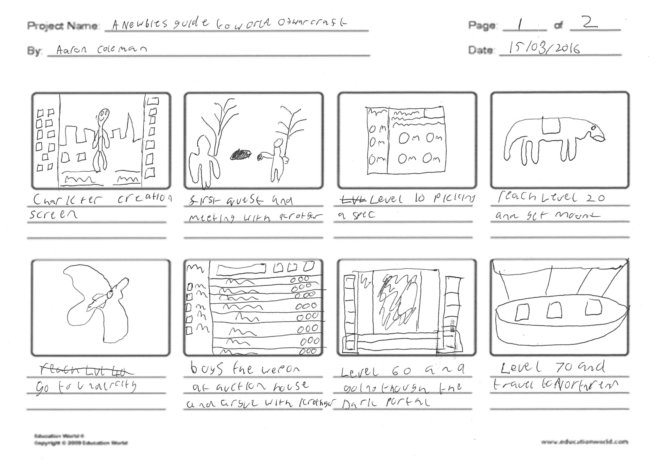

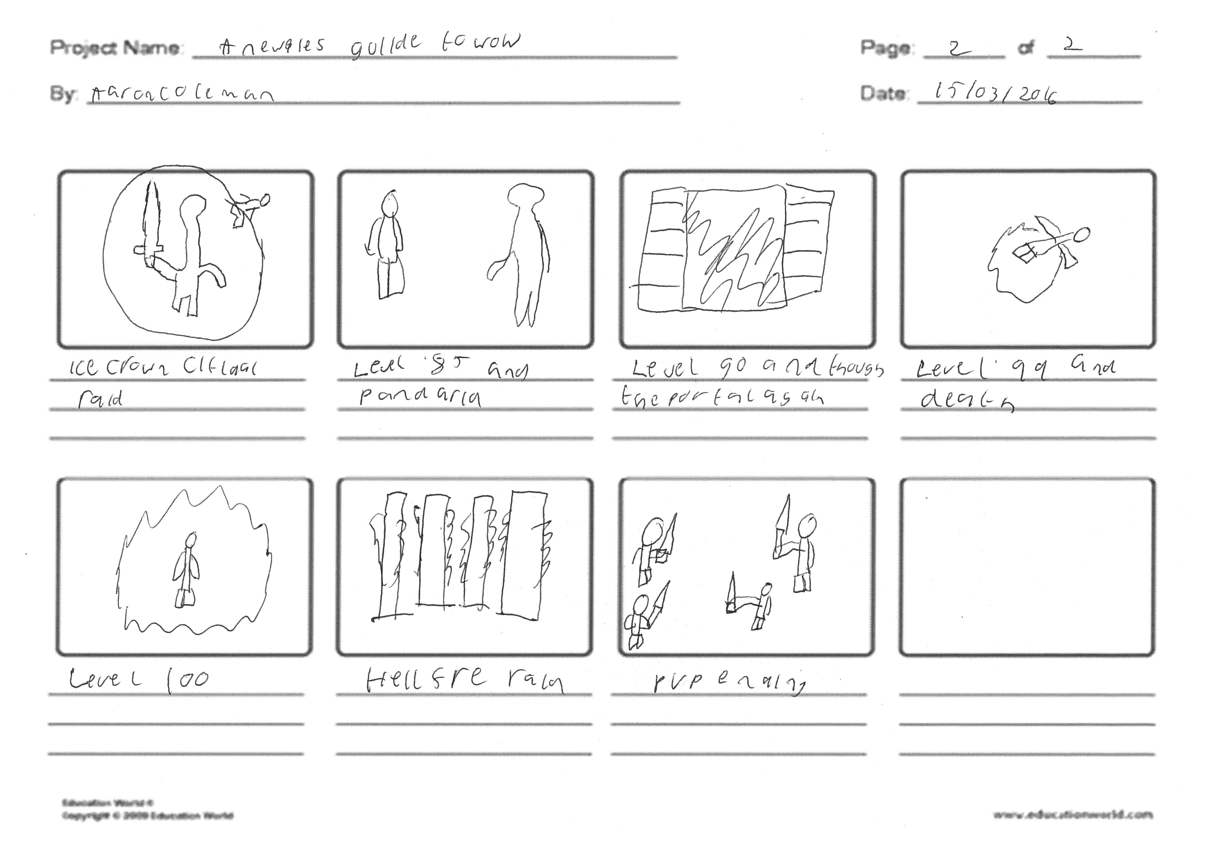

Shot lists

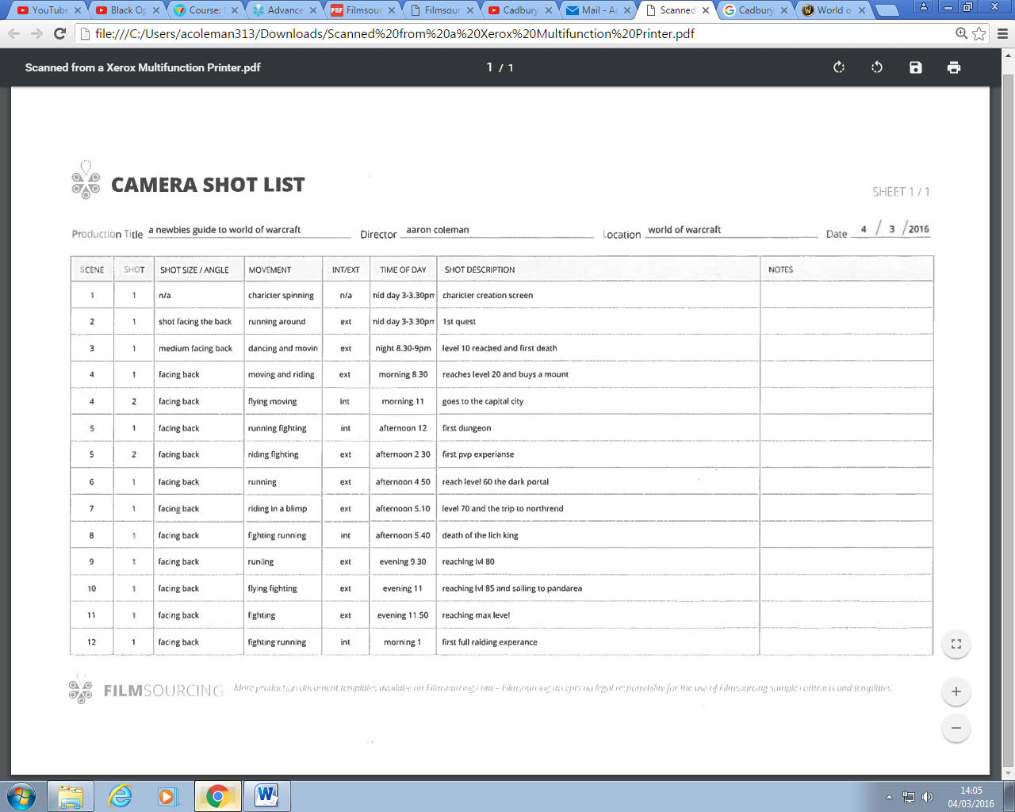

Location scout information, e.g. recce photographs

This idea can be done anywhere there is a computer even at home

Shooting schedules

|  |  |
| --- | --- |
| date | times |
| 1st march | 3-5 pm |
| 3rd march | 3-5 pm |
| 5 march | 3-5 pm |
| 8th march | 3-5 pm |
| 10 march | 3-5 pm |
| 13 march | 3-5 pm |
| 15 march | 3-5 pm |
| 17march | 3-5 pm |
| 20 march | 3-5 pm |

Personnel required

Ben li and I will be handling the project

2 to produce the content and another

Person to edit the end result

Equipment booking

4 computers all with the software shown in costs

Health and safety (risk assessment)

The danger would be being on computers for a period of time and then there will be a lot of wires which can cause a trip hazard but other then that there are no risks

# References

World of Warcraft official site <http://eu.battle.net/wow/en/> date accessed 29/02/2016